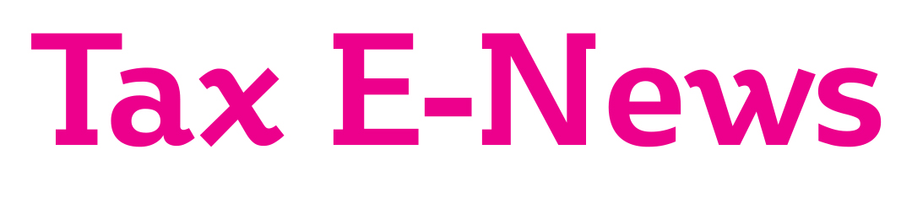

Welcome to this special newswire. In this edition we focus on the Chancellor’s Autumn Budget. Please contact us if you wish to discuss any matters in this newsletter in more detail.

Content accurate as at 28 October 2021

BUDGET AND SPENDING REVIEW

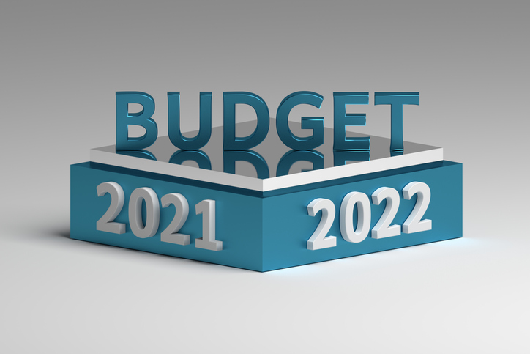

On 27 October 2021, the Chancellor delivered his third Budget in conjunction with the Public Spending Review.
Many of the spending announcements had already been leaked to the Press prior to Budget Day and arguably a lot of it was not new money. The Chancellor did however manage to keep a few surprises back for Budget Day.
Low paid workers will welcome the increases in the National Living Wage (NLW) that take effect from April 2022 and the 8% reduction in the Universal Credit income taper. However, the increase in the NLW in conjunction with the 1.25% increase in National Insurance Contributions (NICs) will be additional costs for employers and are likely to add to inflation.
Rishi Sunak continues to have to tread a fine line between raising taxes to start paying down the massive Government borrowings but at the same time stimulate economic recovery and save jobs.
The changes to tonnage tax and air passenger duty appear to be inconsistent with the goal of reducing CO2 emissions.
NATIONAL LIVING WAGE INCREASED TO £9.50 AN HOUR

Among the announcements leaked before Budget Day was an increase in the hourly rate for the National Living Wage (NLW) which was greater than inflation for those aged 23 or over, to £9.50 an hour. For an employee working a 35-hour week that would mean £17,290 a year. With the 1.25% increase in employers NIC to 15.05% on earnings over £9,100 a year would mean £1,233 on top, the cost to the employer would be £18,523 a year before pension costs.
NO CHANGES TO INCOME TAX RATES AND PERSONAL ALLOWANCE FROZEN

The basic rate of income tax and higher rate remain at 20% and 40% respectively, and the 45% additional rate continues to apply to income over £150,000.
As previously announced in the March Budget, the personal allowance and higher rate threshold have been frozen at £12,570 and £50,270 until 2025/26.

As announced on 7 September, from 6 April 2022 dividend income will be taxed at 8.75%, 33.75% and then 39.35%, depending upon whether the dividends fall into the basic rate band, higher rate band or the additional rate band. The first £2,000 of dividend income continues to be tax-free. The summary of the economic impact published on Budget Day suggests that these rates will remain in place until 2025/26.

SOME NATIONAL INSURANCE THRESHOLDS ARE CHANGING
The 1.25% increase in the rate of National Insurance Contributions (NICs) paid by workers and employers announced on 7 September to provide extra funds for Health and Social care will go ahead from 6 April 2022.
This will become a new Health and Social Care Levy from 2023/24 onwards.

Although the income tax personal allowance and thresholds are frozen until 2025/26, certain NIC thresholds have been increased In line with inflation. For 2022/23, employees and the self-employed will start paying NICs at £9,880 and pay at 10.25% (self-employed) and 13.25% (employees) up to £50,270. Note that the Upper Limit is frozen in line with the income tax higher rate threshold and that the new 3.25% rate will apply to earnings or self-employed profits in excess of £50,270.

Employer contributions at 15.05% will apply to earnings in excess of £9,100 a year for 2022/23.

“TEMPORARY” £1 MILLION ANNUAL INVESTMENT ALLOWANCE EXTENDED

Businesses investing in plant and machinery will welcome yet another extension in the 100% Annual Investment Allowance (AIA) until 31 March 2023. The 100% relief was scheduled to revert to £200,000 on 1 January 2022. This deduction is available to unincorporated businesses as well as limited companies and the equipment does not have to be new.

This tax allowance is not as generous as the 130% super-deduction announced in the March 2021 Budget which is available when new plant and machinery is acquired by limited companies between 1 April 2021 and 31 March 2023.

BUSINESS RATES TO BE MADE “FAIRER” AND 50% DISCOUNT FOR THE RETAIL AND HOSPITALITY SECTOR

The Government continue to promise a fairer system of Business Rates and will provide new reliefs for investment and improvements to business premises. In order to support businesses and jobs in the retail, hospitality and leisure sectors, the chancellor announced a 50% discount in business rates up to £110,000.

High Street businesses still operate at a significant disadvantage to online retailers who generally pay lower Business Rates, and some pay a lot less corporation tax. The Government will consult shortly on an Online Sales Tax which may help level the playing field.
CHANGES TO R&D TAX RELIEF

As announced in the Budget R&D, tax relief will be reformed from April 2023 to support modern research methods by expanding qualifying expenditure to include data and cloud costs, and to focus tax relief on innovation carried out in the UK. HMRC will continue to target abuse of this generous tax relief and improve compliance.

GROUP RELIEF FOR EUROPEAN COMPANY LOSSES TO END

With effect from 27 October 2021, group relief for losses of 75% subsidiary companies resident in the European Economic Area and companies trading in the UK through permanent establishments will end.
CULTURAL TAX RELIEFS DOUBLED
Eligible companies engaged in the production of qualifying theatrical productions, orchestral concerts, and museum and gallery exhibitions are currently able to claim an additional deduction in arriving at their profits. Where that additional deduction results in a loss, the company may surrender those losses for a payable tax credit similar to R&D tax relief.
The doubling of the relief is available for the costs of the production/performance incurred between 27 October 2021 and 31 March 2023.

NEW RESIDENTIAL DEVELOPER TAX

From 1 April 2022 the Government will introduce a new tax on company profits derived from larger UK residential property developers. The tax will be charged at 4% on profits exceeding an annual allowance of £25 million and will be included in the corporation tax returns of those companies liable to the new tax.

MORE TIME TO REPORT AND PAY CGT ON RESIDENTIAL PROPERTY DISPOSAL

Many were expecting big changes to capital gains tax in the Autumn Budget, particularly as the Office of Tax Simplification (OTS) had suggested that CGT rates should be aligned with income tax rates.
The Government have however taken on board the OTS recommendation that the 30 day reporting and payment deadline should be increased to 60 days. This will be a welcome change for property owners and their tax agents and will affect residential property disposals that complete on or after 27 October 2021.
Entrepreneurs will be relieved that CGT Business Asset Disposal Relief continues resulting in a 10% CGT rate on the first £1 million of lifetime gains.

PENSION TAX RELIEF UNCHANGED

There was much speculation that the Chancellor would restrict the tax relief for saving into a pension to basic rate only. Thankfully that has not happened (yet) and the key limits are unchanged. The annual pension input limit for most taxpayers remains at £40,000 which covers both individual and employer contributions. The lifetime pension allowance which dictates the size of the individual’s fund has been frozen at £1,073,100.

INDIVIDUAL SAVINGS ACCOUNT LIMITS FROZEN AGAIN

The adult ISA annual subscription limit for 2022/23 will remain unchanged at £20,000 and the Junior ISA limit remains at £9,000 a year.
DIARY OF MAIN TAX EVENTS
NOVEMBER / DECEMBER 2021

Date | What’s Due
1/11/21 | Corporation tax for year to 31/01/2021 unless quarterly instalments apply
19/11/21 | PAYE & NIC deductions, and CIS return and tax, for month to 5/11/21 (due 22/11 if you pay electronically)
1/12/21 | Corporation tax for year to 28/02/2021 unless quarterly instalments apply
19/12/21 | PAYE & NIC deductions, and CIS return and tax, for month to 5/12/21 (due 22/12 if you pay electronically)
30/12/21 | Deadline for filing 2020/21 tax return online in order to request that HMRC collect outstanding tax via the 2021/22 PAYE code

